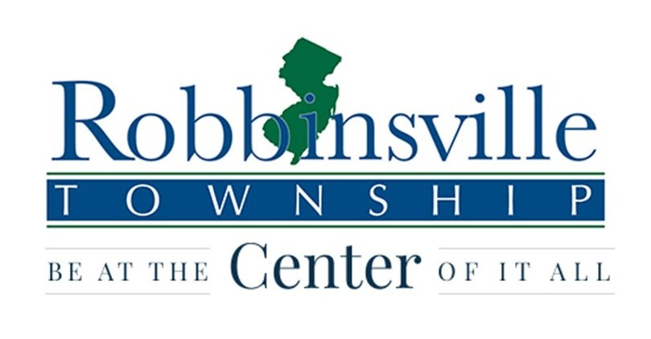
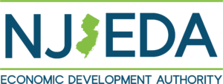

FOR IMMEDIATE RELEASE

TRENTON, NJ – (March 11, 2026) - The New Jersey Motion Picture and Television Commission (NJMPTVC), part of the New Jersey Economic Development Authority (NJEDA), announced on Tuesday that Robbinsville Township - with its unique history and diverse, bucolic and versatile landscape - was one of 15 municipalities added to the state’s growing list of Film Ready Communities.
The Film Ready Program educates municipalities on the basics of motion picture and television production and sets basic standards for attracting filmmaking, expanding economic opportunities for communities across the state in New Jersey’s record-breaking film and television sector.
“New Jersey’s variety of landscapes and locations, from charming main streets and bustling city blocks to rugged mountains and vast farmland, are a major asset for the state’s film and television industry, ensuring producers can find the perfect locale for their next feature film,” NJEDA Chief Executive Officer Evan Weiss said. “The newest cohort of Film Ready Communities will be prepared for the industry’s continued growth, which will support Governor Sherril’s vision to create jobs for residents, support small businesses, and drive meaningful economic growth in municipalities across the Garden State.”
The 15 new Film Ready Communities announced March 11 are: Edison, Fanwood, Garwood, Hamilton, Hanover, Highland Park, Hightstown, Lambertville, New Brunswick, Newton, Oceanport, Phillipsburg, Randolph, Robbinsville, and Shrewsbury. Along with the previous Film Ready cohorts announced in March 2024 and August 2025, New Jersey now has 58 Film Ready Communities.
“Robbinsville Township offers a diverse and dynamic range of filming locations - from historic areas and a vibrant downtown to welcoming neighborhoods, parks, and distinctive landmarks - making it an ideal canvas for filmmakers of all genres,” Mayor Michael J. Todd said. “Achieving NJ Film Ready Certification sends a clear message that we are prepared, responsive, and eager to welcome productions, while creating meaningful economic opportunities for our local businesses and strengthening our community without placing additional burden on residents. We look forward to the creative partnerships ahead and to showcasing everything our town has to offer.”
Film Ready New Jersey is a 5-step certification and marketing program that prepares communities to accommodate movie and television producers and effectively market themselves as film destinations. The NJMPTVC’s Film Ready Workshops provide training and guidance from industry professionals, local mayors, and NJMPTVC Commissioners and staff, covering topics such as the economic impact of hosting on-location filming, ordinances and permitting, opportunities for small businesses, and expanding film infrastructure.
The goal of the program is to incentivize production companies to film and create digital media content in New Jersey.
“As film and television production continues to break records in New Jersey, local communities need to be prepared to handle the unique needs of the industry,” NJMPTVC Executive Director Jon Crowley said. “The Film Ready Program establishes statewide consistency and provides expert guidance on everything from permitting to public safety management, strengthening the state’s industry leadership as more producers choose the Garden State for their next big production.”
In May of 2025, Netflix and State officials broke ground at Fort Monmouth to begin construction for a new state-of-the-art movie and television production facility.
Netflix plans to invest $1B to transform the 292-acre former US Army installation, which sat vacant for nearly a decade, into a premier East Coast production hub. It is scheduled to open in 2028.
-RT-

